Activity: Exploring EV Evacuation Routing and Mobile Charging Station Deployment
1. Summary
In this activity, participants use the EV evacuation optimization code to study how mobile charging-station availability, initial EV driving range, and evacuation flow affect feasible routing, charging decisions, evacuation time, and MCS deployment. Participants first run a baseline case, then change selected parameters and compare the modified results with the baseline.

The workflow mirrors a baseline-versus-modified-scenario exercise: record assumptions, predict the effect of a change, run the code, record the terminal summary, and interpret the differences.

2. Learning objectives
- Explain how the total number of available MCSs can affect routing feasibility and charging support.
- Explain how initial EV driving range can change the need for FCS/MCS charging along an evacuation route.
- Explain how OD-pair evacuation flow can affect road and charging-capacity constraints.
- Compare baseline and modified optimization results using charging time, travel time, total evacuation time, and MCS deployment.
- Identify parameter combinations that make the optimization difficult to solve or infeasible.

3. Preparation and materials
- A computer with Python and the packages required by the repository.
- The optimization script and its supporting solver/data files.
- A working baseline case that produces a feasible solution.
- This participant worksheet for recording baseline and modified results.

Before the activity, the instructor should run the baseline case once and verify that the terminal summary and route plots are produced. Participants should modify only the designated parameters shown in this worksheet.

4. Baseline scenario
Use the current default values in the optimization code as the baseline.
Parameter | Baseline value | Where it is changed
Total number of available MCSs | 25 | num_MCS
Initial flow - each of 7 OD pairs | 60 Veh/hr | init_flow
Initial range - each of 7 OD pairs | 20 km | init_range
Number of OD pairs | 7 | start_node_centroid / goal_node_centroid

5. Baseline OD pairs and inputs
OD pair | Start centroid | Goal centroid | Initial flow (veh/hr) | Initial range (km)
OD 1 | 51736 | 50623 | 60 | 20
OD 2 | 51731 | 50626 | 60 | 20
OD 3 | 50668 | 50606 | 60 | 20
OD 4 | 50662 | 50611 | 60 | 20
OD 5 | 50659 | 50614 | 60 | 20
OD 6 | 50677 | 51851 | 60 | 20
OD 7 | 50637 | 51874 | 60 | 20

6. Suggested agenda
Stage | Time
Instructor introduces the model, baseline case, and editable parameters | 10 minutes
Groups predict outcomes and run the baseline | 10 minutes
Groups modify one or more assigned parameters and rerun | 20 minutes
Groups compare baseline and modified results | 15 minutes
Groups report findings | 5 minutes

7. Activity instructions

Part A - Predict and run the baseline

Before running the baseline, discuss:
1. How many OD pairs do you expect will require charging?
2. Which input is likely to have the strongest effect on feasibility: total MCS availability, initial range, or OD-pair flow?
3. If the total number of available MCSs is reduced, do you expect travel time, charging time, MCS deployment, or feasibility to change first?

Run the baseline and save or copy the terminal summary. Record the results in the participant worksheet.

Part B - Change selected parameters

Restore the baseline before each independent experiment unless your instructor specifically asks for a combined scenario. Participants may change the total MCS availability, the initial range of one or more OD pairs, and/or the flow of one or more OD pairs.

Example investigation | Parameter change
Limited mobile-charging resources | Reduce num_MCS below the baseline value of 25.
Improved mobile-charging resources | Increase num_MCS above 25.
Low-range OD pair | Reduce init_range for one or more selected OD pairs.
Higher evacuation demand | Increase init_flow for one or more selected OD pairs.
Combined stress case | Reduce range while increasing flow and/or reducing MCS availability.

8. How to change the parameters in the code
Open the main optimization script and locate the baseline OD-pair input block. Change only the values inside init_flow and init_range; keep the number of entries equal to the number of OD pairs.

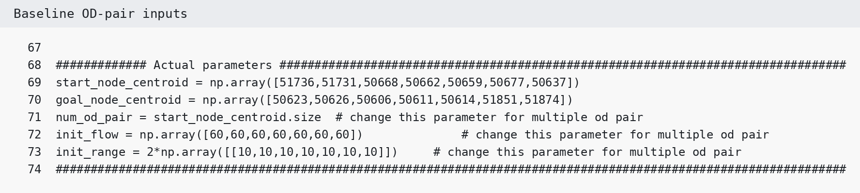
Figure 1. Baseline OD-pair input block in the optimization code.
Example: to change only OD 1 from 60 EVs and 20 km to 80 EVs and 15 km, edit the first entry in each array:

Baseline | Example modified case
init_flow = [60,60,60,60,60,60,60]  init_range = 2*[[10,10,10,10,10,10,10]] | init_flow = [80,60,60,60,60,60,60]  init_range = [[15,20,20,20,20,20,20]]

Note: init_range is the initial driving range in kilometers. In the baseline code, 2*np.array([[10,...]]) produces 20 km for every OD pair. You may either keep the multiplier form or directly enter the desired kilometer values in the array.

To change the total number of MCSs available to the optimization, locate num_MCS in the MCS parameter section.
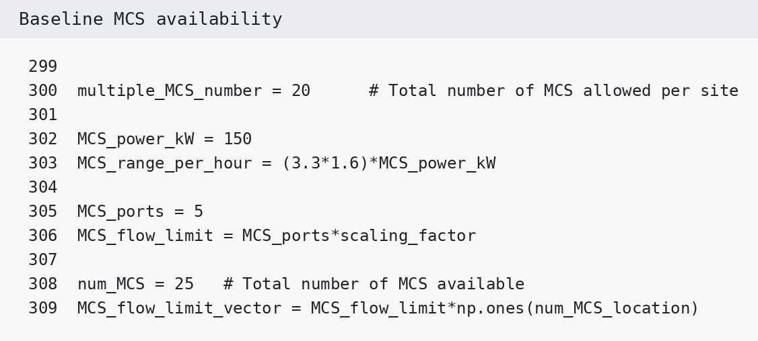
Figure 2. Baseline total MCS availability in the optimization code.
For example, change num_MCS = 25 to num_MCS = 15 to study a resource-constrained case. After changing inputs, save the file and rerun the optimization.

Participant Worksheet
Group members: __________________________________________________________________________
Assigned scenario / question: ________________________________________________________________

1. Record your assumptions

Complete the modified-scenario column. Leave all other parameters at their baseline values unless instructed otherwise.

Input | Baseline | Modified scenario
Total number of available MCSs | 25
OD 1 flow: 51736 -> 50623 | 60
OD 1 initial range (km) | 20
OD 2 flow: 51731 -> 50626 | 60
OD 2 initial range (km) | 20
OD 3 flow: 50668 -> 50606 | 60
OD 3 initial range (km) | 20
OD 4 flow: 50662 -> 50611 | 60
OD 4 initial range (km) | 20
OD 5 flow: 50659 -> 50614 | 60
OD 5 initial range (km) | 20
OD 6 flow: 50677 -> 51851 | 60
OD 6 initial range (km) | 20
OD 7 flow: 50637 -> 51874 | 60
OD 7 initial range (km) | 20

2. Predict the effects before running the modified case

Output | Predicted change | Reason
Feasibility
Charging time
Travel time
Total evacuation time
Total deployed MCSs

3. Record the baseline optimization results

Use the terminal summary generated by the optimization code. Record time in minutes and MCS counts exactly as reported.

OD pair | Charging time  (min) | Travel time  (min) | Total evacuation  (min) | MCS used | Feasible?
OD 1  51736->50623 |  |  |  |  | Yes / No
OD 2  51731->50626 |  |  |  |  | Yes / No
OD 3  50668->50606 |  |  |  |  | Yes / No
OD 4  50662->50611 |  |  |  |  | Yes / No
OD 5  50659->50614 |  |  |  |  | Yes / No
OD 6  50677->51851 |  |  |  |  | Yes / No
OD 7  50637->51874 |  |  |  |  | Yes / No

4. Record the modified-scenario results

OD pair | Charging time  (min) | Travel time  (min) | Total evacuation  (min) | MCS used | Feasible?
OD 1  51736->50623 |  |  |  |  | Yes / No
OD 2  51731->50626 |  |  |  |  | Yes / No
OD 3  50668->50606 |  |  |  |  | Yes / No
OD 4  50662->50611 |  |  |  |  | Yes / No
OD 5  50659->50614 |  |  |  |  | Yes / No
OD 6  50677->51851 |  |  |  |  | Yes / No
OD 7  50637->51874 |  |  |  |  | Yes / No

5. Aggregate comparison
Metric | Baseline | Modified | Main observation
Total initial flow
Total / available MCSs
Total deployed MCSs
Average OD evacuation time (min)
Maximum OD evacuation time (min)
Number of OD pairs using MCS charging

6. Compare the baseline and modified cases
For each question, support your answer with values from the terminal summary or route plots.
1. Which OD pair changed the most in total evacuation time? Why?
________________________________________________________________________________________________________
________________________________________________________________________________________________________
2. Did changing initial range mainly affect charging time, route choice, MCS deployment, or several of these?
________________________________________________________________________________________________________
________________________________________________________________________________________________________
3. Did increasing flow create a capacity bottleneck on roads, at FCS locations, or at candidate MCS locations?
________________________________________________________________________________________________________
________________________________________________________________________________________________________
4. How did changing the total number of available MCSs affect the number actually deployed?
________________________________________________________________________________________________________
________________________________________________________________________________________________________
5. Did any modified case reach the solver time limit? If yes, was a feasible solution found before the limit?
________________________________________________________________________________________________________
________________________________________________________________________________________________________
6. If no feasible solution was found, which input change appears most responsible?
________________________________________________________________________________________________________
________________________________________________________________________________________________________
7. Attach evidence from the run
Paste a screenshot of the baseline terminal summary or route plot in the box below.
Baseline screenshot / plot
Paste a screenshot of the modified terminal summary or route plot in the box below.
Modified-case screenshot / plot

8. Develop recommendations

Based on the comparison, recommend two changes that could improve evacuation readiness or robustness. Recommendations may involve mobile charging resources, pre-evacuation charging/range, traffic management, or demand management.

Proposed improvement | Supporting result | Implementation constraint / information needed

9. Prepare your group report

Question | Group response
What parameter did your group change?
What was your most important finding?
Which OD pair was most sensitive to the change?
How did MCS deployment change?
What limitation of this analysis should be considered when interpreting the result?
What additional local data would improve the analysis?

10. Instructor / participant notes
________________________________________________________________________________________________________
________________________________________________________________________________________________________
________________________________________________________________________________________________________
________________________________________________________________________________________________________
________________________________________________________________________________________________________
________________________________________________________________________________________________________
________________________________________________________________________________________________________
________________________________________________________________________________________________________
Template structure adapted from the uploaded participant worksheet format; optimization inputs and outputs are tailored to the EV evacuation routing/MCS code.

